# Chapter 5: Testing

Testing can be defined as the action to verify whether the genuine outcomes coordinate the normal outcomes and guarantee the product is bug free. The main purpose of testing strategy is to meet the user requirements after software deployment.

The types of testing method I have used in my project are as described below: -

1. **Black box testing: -**

It is a software testing strategy in which internal structure, design of a product is verified without understanding the code or internal structure. The tester is unknown to the system. The image for black box testing is demonstrated below: -

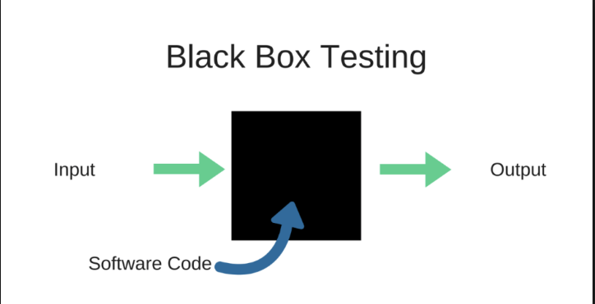

**Test plan: -**

Here below there are some activities which has been tested significantly and a document is created. The test case table for black box table is shown blow: -

|  |  |  |  |  |  |
| --- | --- | --- | --- | --- | --- |
| **Test case** | **Test case description** | **Test data** | **Expected data** | **Actual data** | **Status** |
| **1** | Checking signup of User | Signup form | Signup and redirect to login form | Signup successful and redirect to login form | pass |
| **2** | Checking login of user with invalid username | Username=saudrajendra  Password=infineiniesta | Login successful | Login failed | fail |
| **3** | Checking login of user | Username=rajendra12345  Password=infineiniesta | User login and redirect to homepage | Login successful and redirect to home page | pass |
| **4** | Search product | Search=mobiles  Price range=2000-3500  Category= phones | Searching successful | Search unsuccessful | fail |
| **5** | Edit account for users | Customer account edit form | Data edit successful | Account editable successful | pass |
| **6** | Password changing for user | Old password=infineiniesta123  New password= ronaldo7 | Password should be changed | password changed successfully | pass |
| **7** | Ordering item | Add to ordered cart | Item is ordered | Item is not ordered | fail |
| **8** | Checking login of admin | Username=administrator  Password=admin123456 | Logged in successfully | Login unsuccessful | fail |
| **9** | Checking login with valid username and password | Username=administrator  Password=admin123 | Login must be successful | Login successful | pass |
| **10** | Add products | Add product form | Product must be added successfully | Added successfully | pass |
| **11** | Update product by admin | Update form | Product updated successfully | Updating product failed | fail |
| **12** | Delete product by admin | Delete form | Product is deleted successfully | Product deleted successfully | pass |
| **13** | Manage order by admin | Order management form | Verifying order successfully | Order not verified by admin | fail |
| **14** | Update products with filling form completely | Product update form | Product updated | Product updated successfully | pass |
| **15** | Password changing of admin | Old password=admin123  New password=admin12345 | Password must be changed | Password has been changed | pass |
| **16** | Search product | Search=laptops  Price range=100-3200  Category=electronics | Search result must be seen | Search result successful | pass |
| **17** | Deleting unnecessary order by admin | Delete id=1 | order must be deleted | order is deleted successfully | pass |
| **18** | Ordering items without login into the system | Order item | Item ordered | Item is not ordered | fail |
| **19** | Customer registration without filling complete form | Signup form | Signup successful | User can’t signup | fail |
| **20** | Ordering product with valid quantity | Order product | Product verified successfully | Order verified | pass |

**Test case:1**

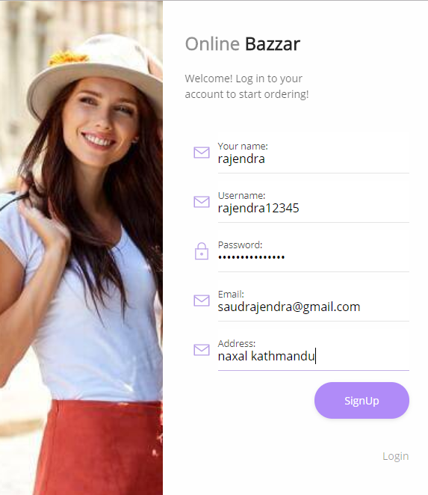

***Fig: signup successful and redirect to login form***

**Test case:2**

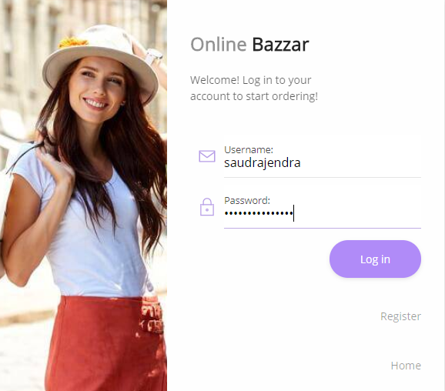

***Login with invalid username***

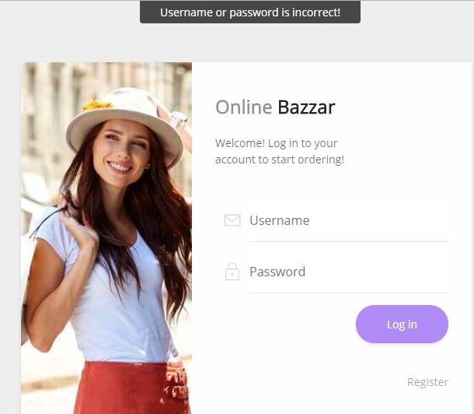

***Fig: customer login failed***

**Test case:3**

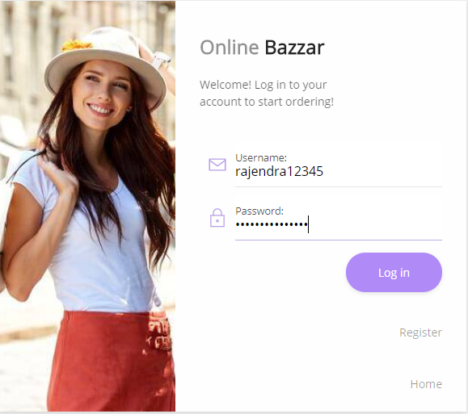

***Fig: login successful***

After successful login of user is redirected to home page where they can search the product as their need and requirements.



***Fig: home page for logged in users***

**Test case:4**

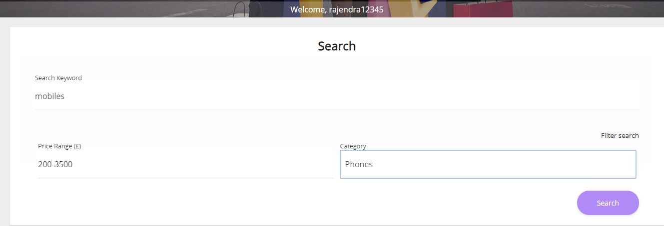

***Fig: product searching for users***

As the needs and requirement of the customer there is no any product is added to the system so the searching result for customer is failed.

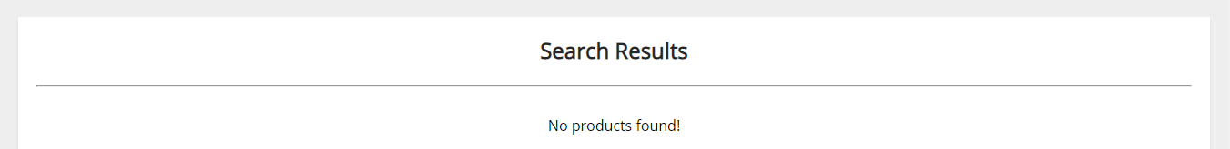

***Fig: product not found***

**Test case:5**

The customer can edit their account as their need. Here the customer has change his address.

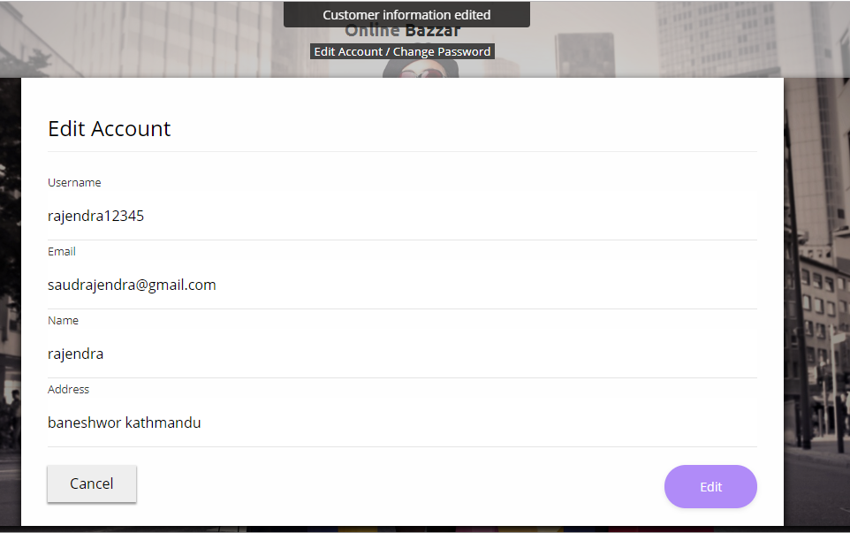

***Fig: customer data edited***

**Test case:6**

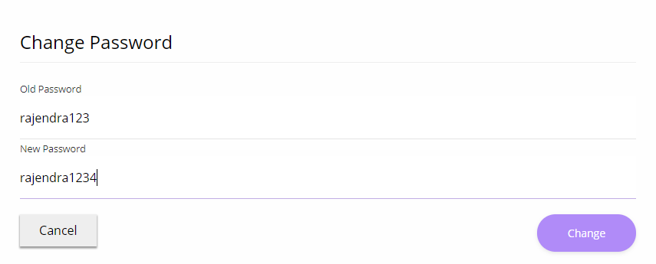

***Fig: password changing form for customer***

Here customer has changed his password by providing old password and new password has been set.

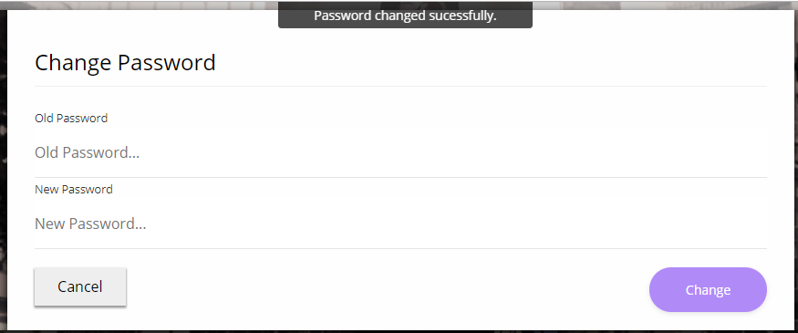

***Fig: password changed successfully***

**Test case:7**

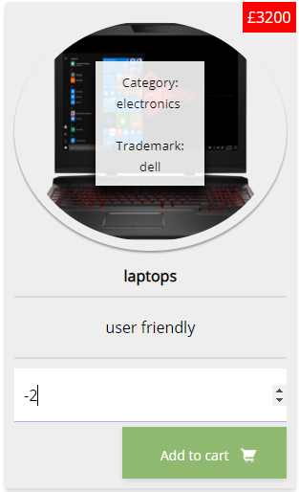

***Fig: ordering item***

The item which is ordered by the customer is not verified because the quantity ordered in in negative marking so the order verified false.

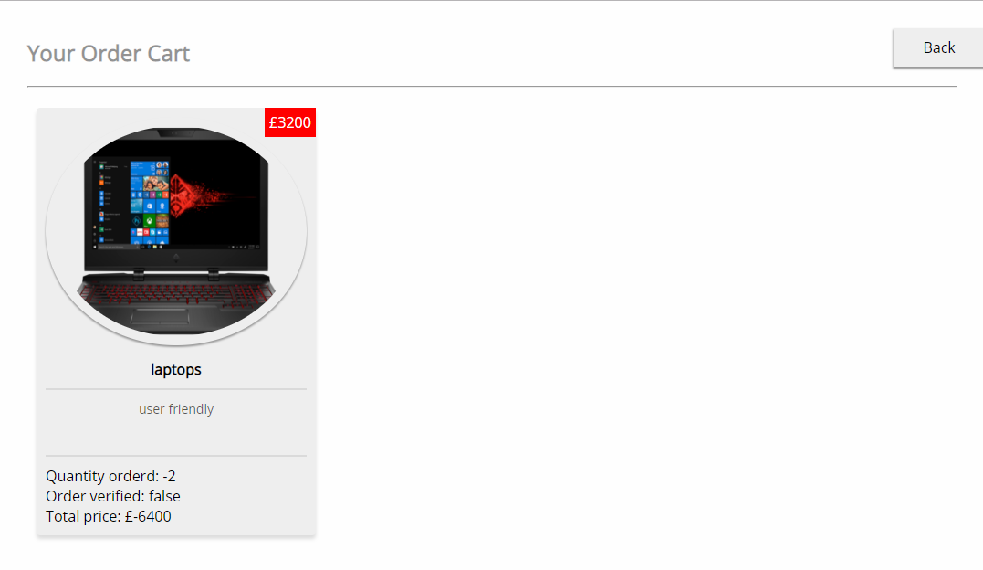

***Fig: ordering item is not verified***

**Test case:8**

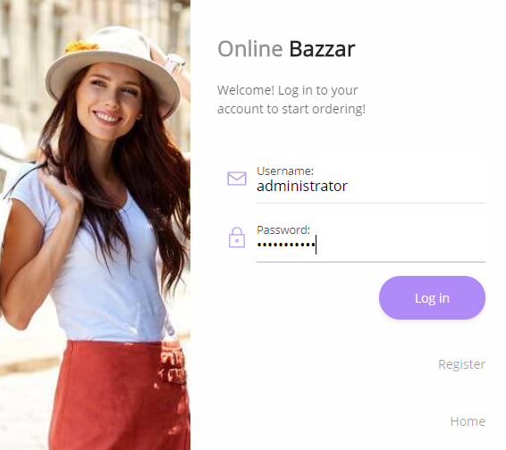

***Fig: log in form for admin***

Because of wrong username or password admin is unable to access the system i.e. not logged into the system.

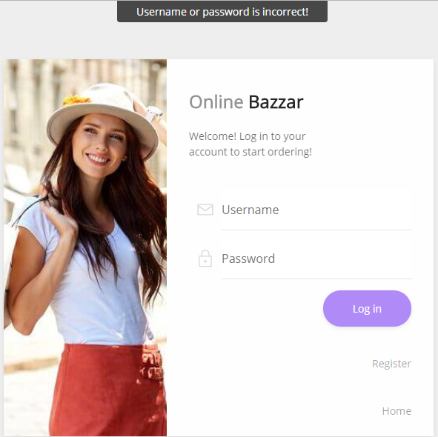

***Fig: login unsuccessful for admin***

**Test case:9**



***Fig: user login with valid username and password***



***Fig: successful login of administrator***

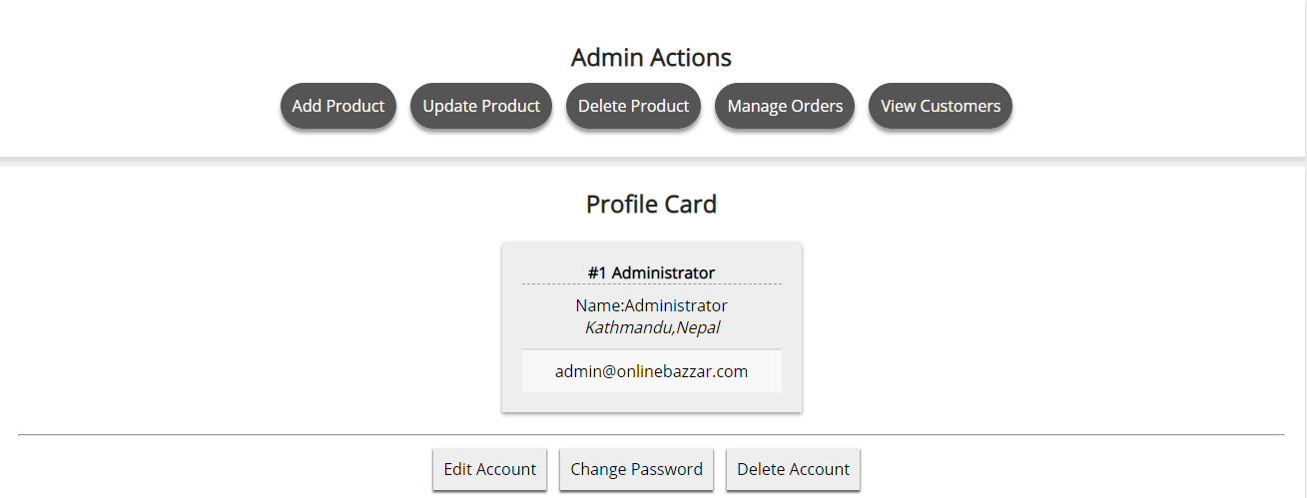

***Fig: Admin actions.***

**Test case:10**

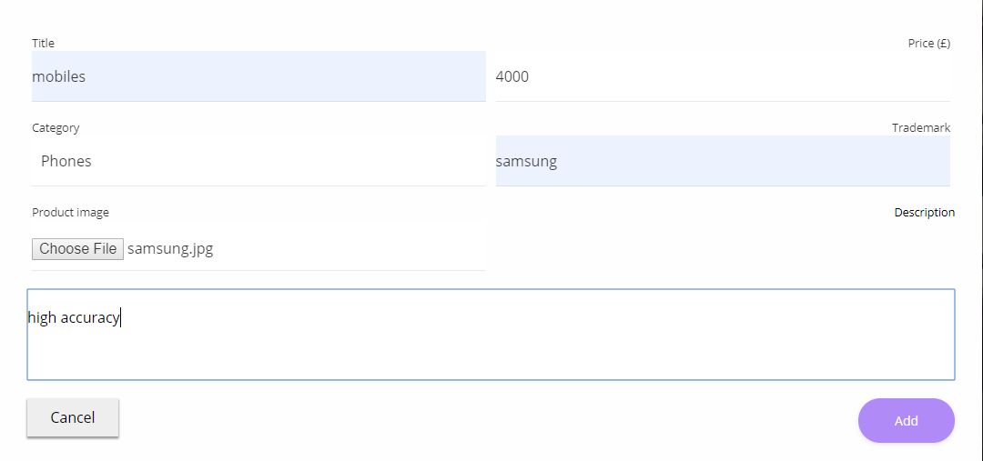

***Fig: add product form.***

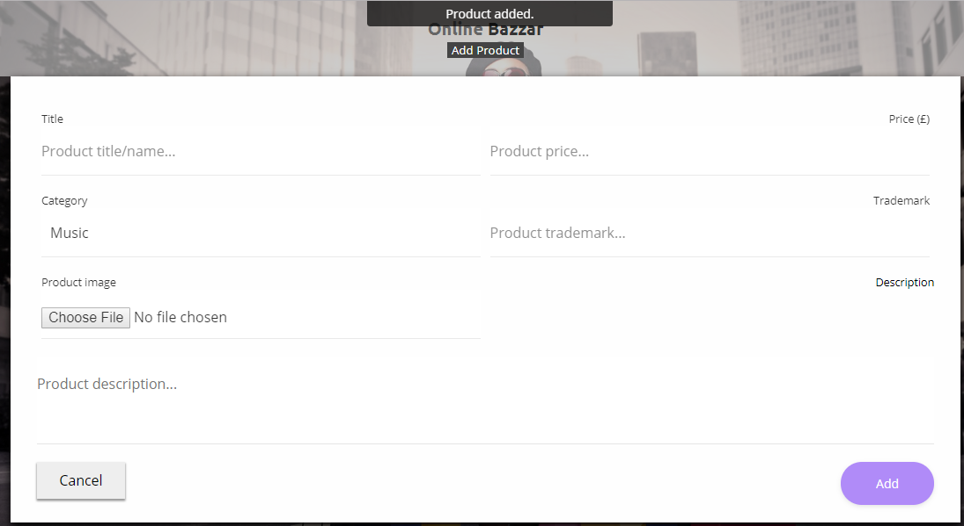

***Fig: product added by admin successfully.***

**Test case:11**

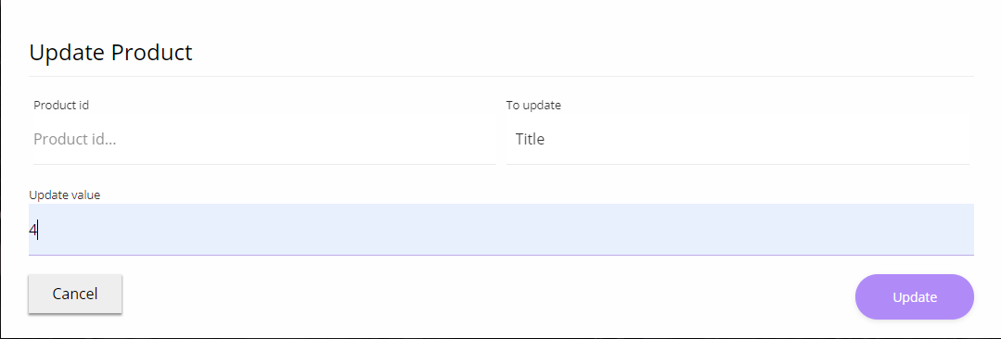

***Fig: product update form for admin***

Here there are some missing characters to fill up the form so the product is not updated

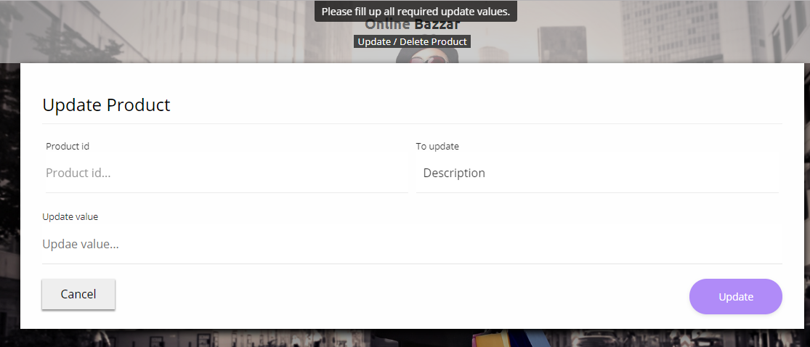

***Fig: message is seen to fill up all values***

**Test case:12**

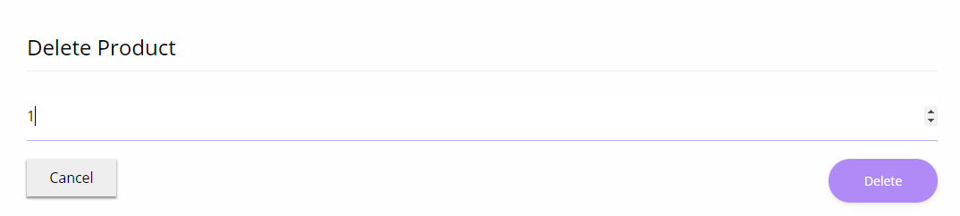

***Fig: delete product form for admin***

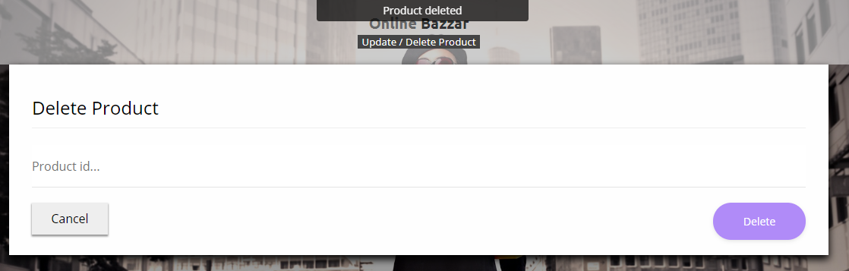

***Fig: product deleted sucessfully***

**Test case:13**

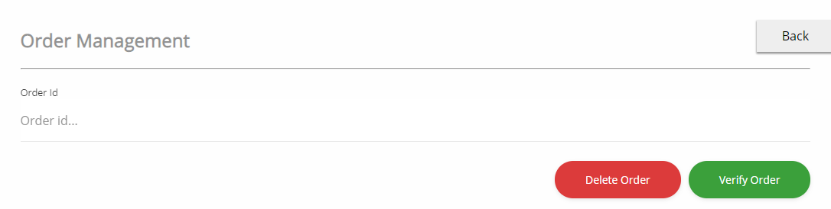

***Fig: order management form***

Here the admin is missing to insert the order id number for verifying order so the order management is unsuccessful.

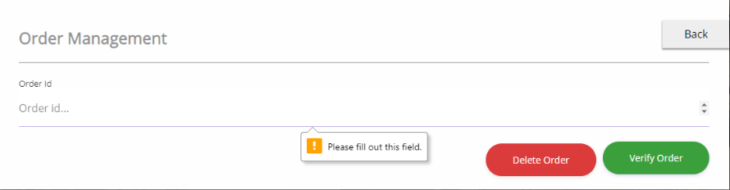

***Fig: message is seen to fill out the field.***

**Test case: 14**

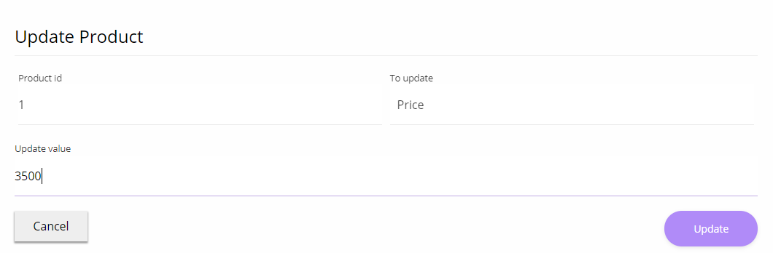

***Fig: product price is updating by admin***

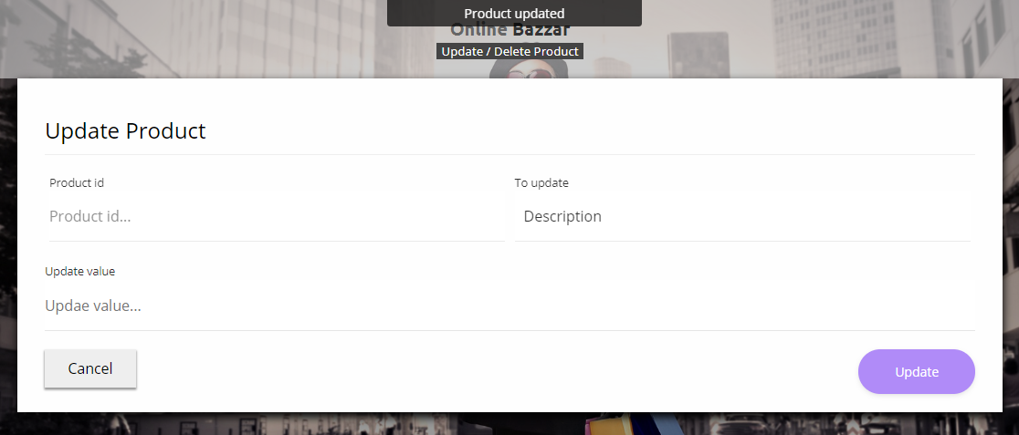

***Fig: price updated successfully***

**Test case:15**

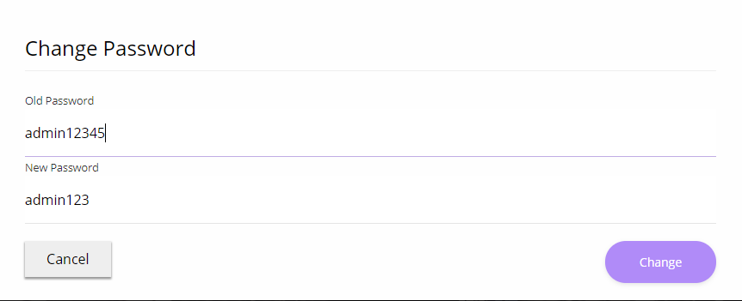

***Fig: password changing for admin***

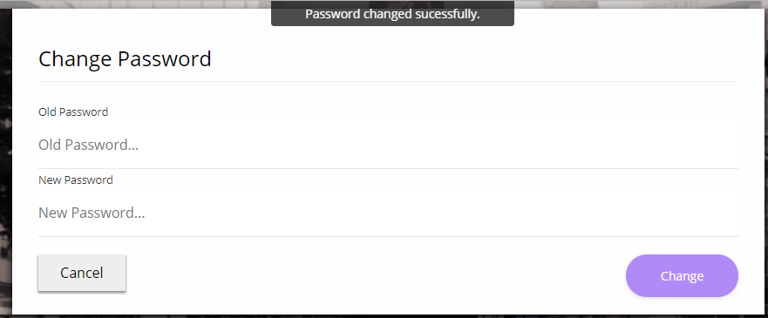

***Fig: password has been changed successfully***

**Test case:16**

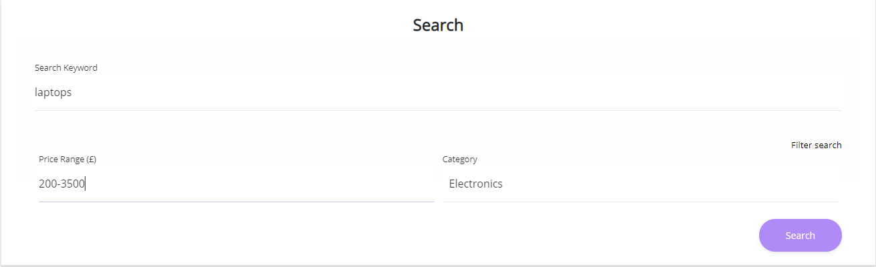

***Fig: searching for product with filling the form completely***

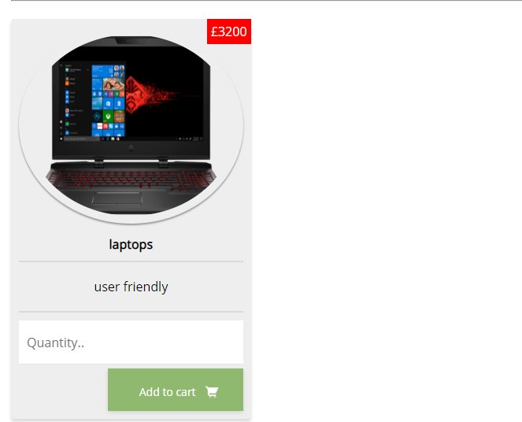

***Fig: product is seen as the customer needed***

**Test case:17**

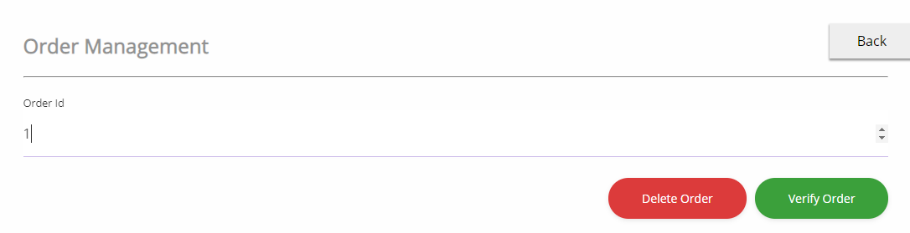

***Fig: Delete order form***

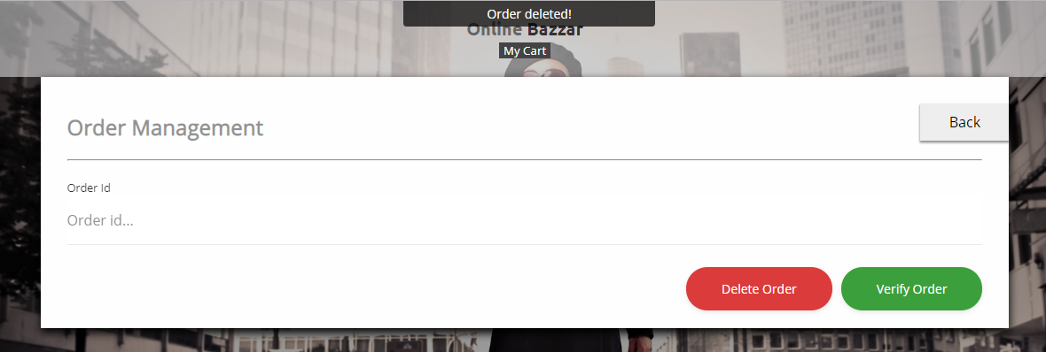

***Fig: Customer order deleted successfully***

**Test case:18**

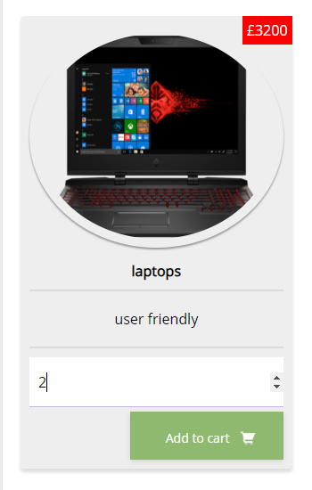

***Fig: Ordering item without login into the system***

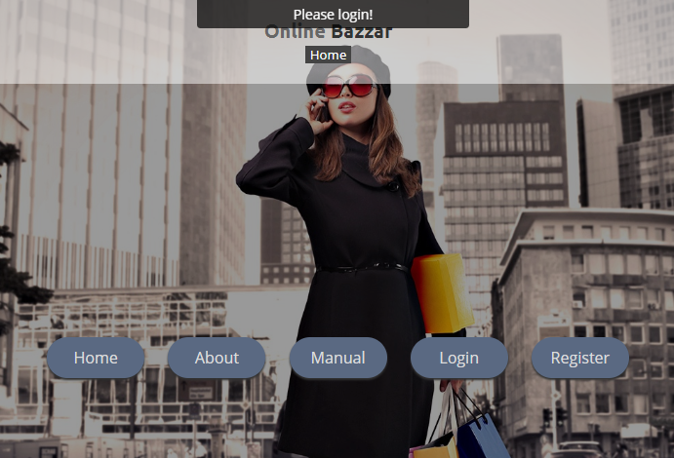

***Fig: cannot order item and a message is seen***

**Test case:19**

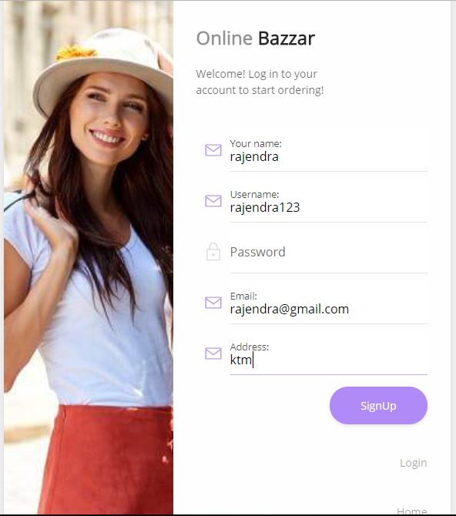

***Fig; Customer registration without filling form completely***

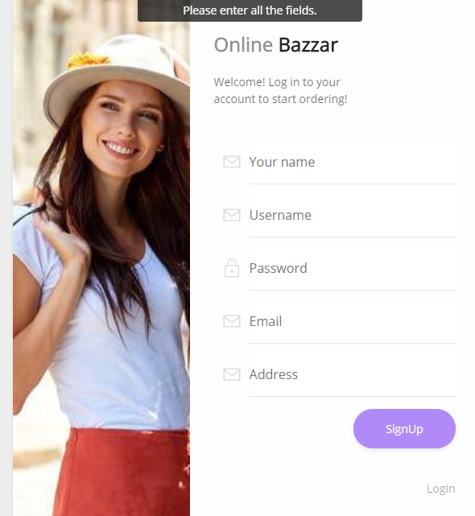

***Fig: Register unsuccessful and message is seen***

**Test case: 20**

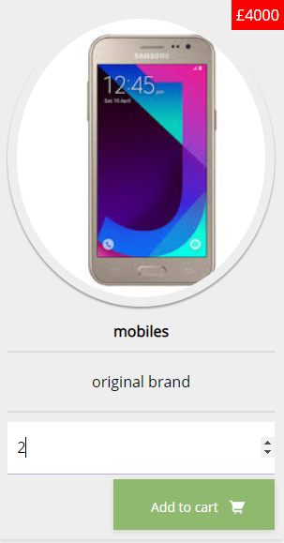

**Ordering product with valid order no**

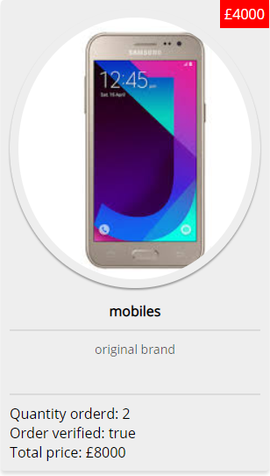

**Order verified successfully.**

1. **Unit testing: -**

It is a software development process which is used to test each and every little testable pieces of the product. Unit testing should be possible physically yet it is frequently mechanized and usually done by the white box testing. The image for unit testing is shown below: -

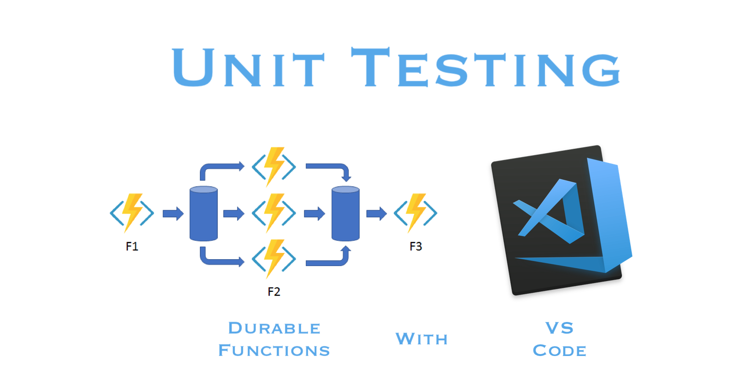

**Test plan: -**

Here below there are some activities which has been tested significantly and a document is created. The test case table for unit testing are shown blow: -

**Test case:1**

|  |  |
| --- | --- |
| **Test case** | 1 |
| **Test case description** | Test user login |
| **Test data** | Username=saudrajendra  Password=rajendra123 |
| **Expected data** | Successful login |
| **Actual data** | User login successfully |
| **status** | pass |

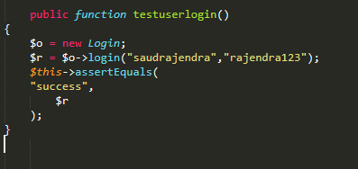

**Fig: Testing user login with username and password**

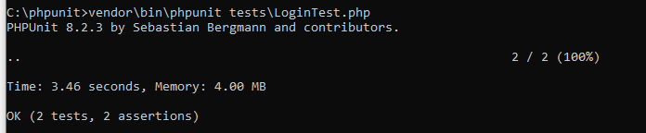

***Fig: User login successful***

**Test case:2**

|  |  |
| --- | --- |
| **Test case** | **2** |
| **Test case description** | Testing signup for the customer |
| **Test data** | Username=rajendra  [**Email=saudrajendra@gmail.com**](mailto:Email=saudrajendra@gmail.com)  Name=rajendrsaud  Address: ktm |
| **Expected data** | Update info successful |
| **Actual data** | Updating information unsuccessful |
| **status** | fail |

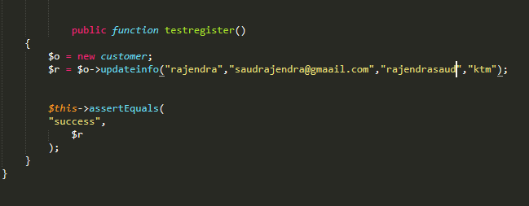

***Fig: Testing updating info of the customer***

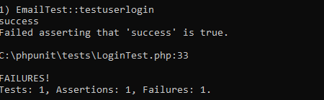

***Updating customer information failed***

**Test case: 3**

|  |  |
| --- | --- |
| **Test case** | **3** |
| **Test case description** |  |
| **Test data** | Username=rajendra  [**Email=saudrajendra@gmail.com**](mailto:Email=saudrajendra@gmail.com)  Name=rajendrsaud  Address: ktm |
| **Expected data** | Update info successful |
| **Actual data** | Updating information unsuccessful |
| **status** | fail |

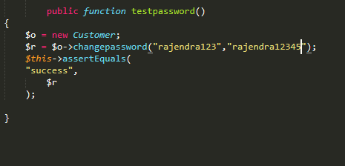

***Fig: testing customer password changing process***

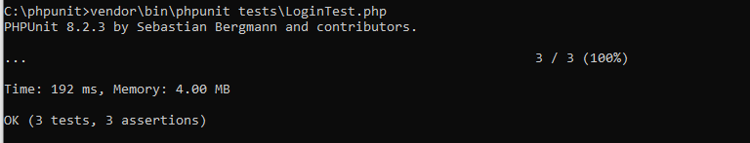

***Fig: changing password successful***